Individual Report Summary for Charlie Ogilby
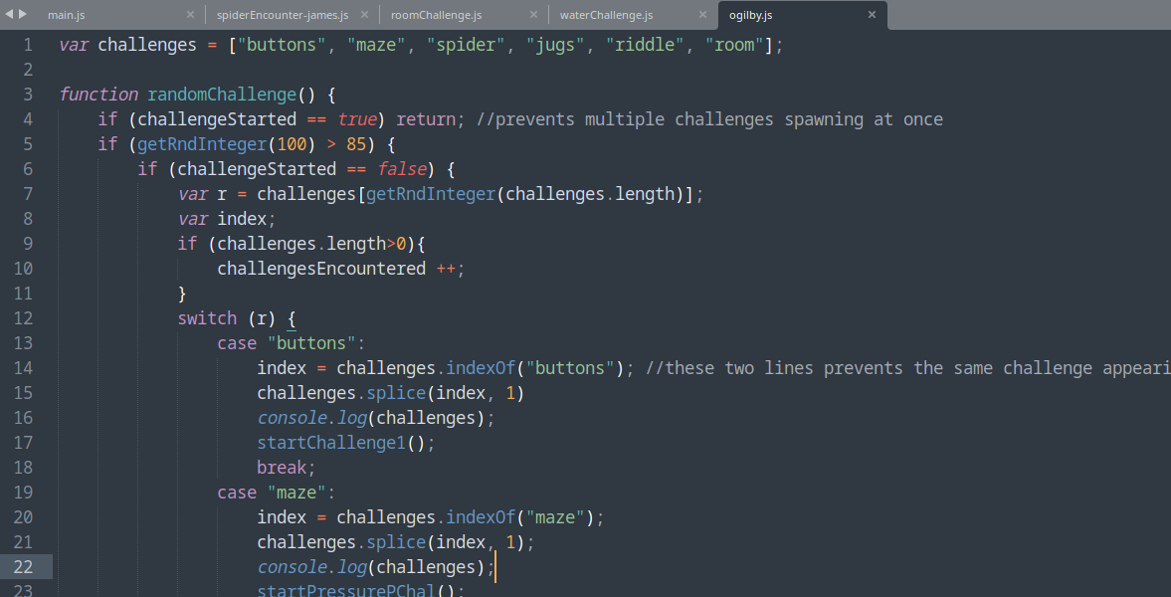
One of the things I did for Oubliette was that I implemented how challenges are encountered. I added a function that is called every time the player moves and which has a chance of spawning a challenge. The way challenges are randomised was made compatible with the seed feature, so that every challenge appears in the same sequence and after the same number of moves, granted the seed is the same.

I also did the music and sound effects. I created the sound effects using https://sfxr.me/ and sourced one from YouTube (deemed free to use by its creator), and declared them in the index.html page so that I could use them throughout the project. There are sound effects for clicking, moving, winning, losing, and pouring water. As for the music, I sourced two theme-consistent background music tracks from Kevin MacLeod. One is played throughout the game; the other is only played during the spider challenge. I used Audacity to edit the music tracks, ensuring a clean transition between the two.
I also made sure to properly attribute anyone I took assets from in the game.
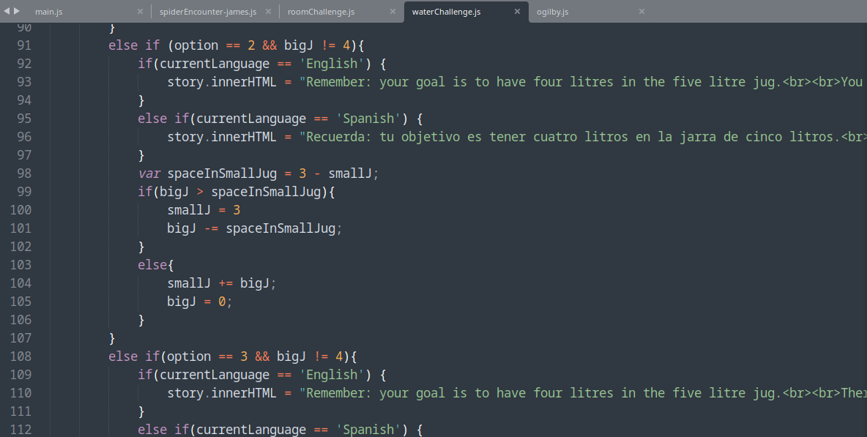
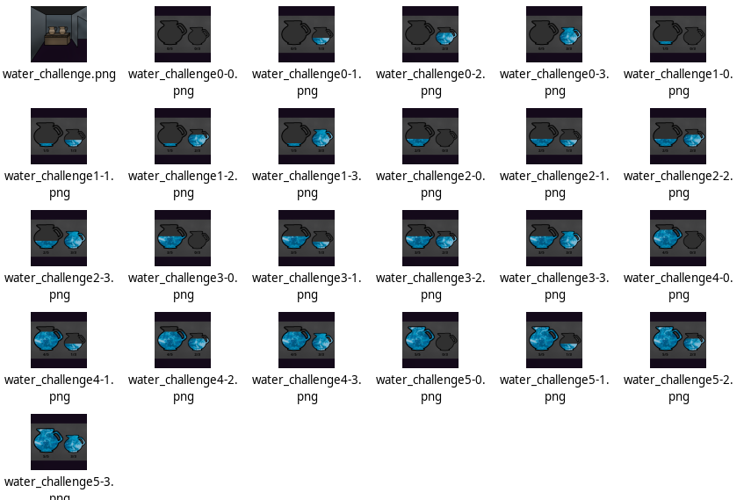
I coded and made the art for a puzzle challenge based around jugs of water involving a five-litre jug and a three-litre jug, where the objective is to get four litres in the five litre jug (see https://en.wikipedia.org/wiki/Water_pouring_puzzle for more info). Because this puzzle is more unwieldy than the others, I implemented a diagram screen showing the water in each jug corresponding to the player’s decisions so far, so the player can track their progress. This involved created 24 different images, although only about half of that are possible to achieve with the four options I gave the player (adding more options would make it too confusing for a 5-min game).

As for other things I did, I wrote the CSS for the story box, made images for the torch, the spider on fire, and the Spanish versions of the riddle challenge, the plates challenge, and the spider challenge; I also implemented around 40% of the Spanish translations (machine-translated) and made sure the special Spanish characters like ñ showed up properly by using HTML character codes. I also did a lot of minor bugfixing like ensuring the end screen pops up if you die in the middle of a challenge, and other such minutia.

